

***PMAS ARID AGRICULTURE UNIVERSITY RAWALPINDI***

***INSTITUTE OF INFORMATION AND TECHNOLOGY***

**SUBJECT: SOFTWARE CONSTRUCTION**

**ARID NO: 20-ARID-773**

**CLASS: BSSE-5B**

**SUBMITTED BY: JAVERIA ABBASI**

**SUBMITTED TO: SIR AZHAR**

**DATE: 27-11-2022**

**CLASS DIAGRAM:**

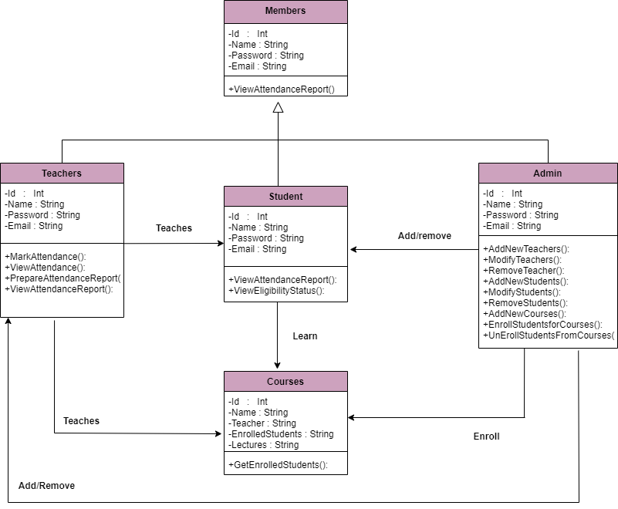

CODE:

package javaapplication6;

class Members

{

private int id;

private string name;

private string password;

private string email;

public void ViewAttendanceReport()

{

}

}

class Teacher extends Members

{

@override

public void ViewAttendanceReport()

{

}

public void AddLectures()

{

}

public void MarkAttendance()

{

}

public void PrepareReport()

{

}

}

class Admin extends Members

{

@override

public void ViewAttendanceReport()

{

}

public void AddNewTeachers()

{

}

public void RemoveTeachers()

{

}

public void AddStudents()

{

}

public void RemoveStudents()

{

}

public void Modify()

{

}

public void AddNewCourses()

{

}

public void EnrollStudentsforCourses()

{

}

public void UnenrolledStudentsFromCourses()

{

}

}

class Student extends Members

{

@override

public void ViewAttendanceReport()

{

}

public void ViewEligibilityStatus()

{

}

}

class Courses

{

private int Id;

private String Name;

private String Teacher;

private String EnrolledStudents;

private String Lectures;

public void GetEnrolledStudents()

{

}

}

public class JavaApplication6 {

public static void main(String[] args) {

}

}